User Guide 32 Applying for a Certificate Manager digital certificate
Purpose of this Guide
The purpose of this guide is to provide information on how to apply for a Certificate Manager digital certificate.

Notes
- This guide follows on from User Guide 31.
- You cannot enrol for a digital certificate until DigiCert confirms that an account has been created for your organisation. DigiCert will email the nominated contact person in your organisation once an account has been established.
- Securely record your passwords.
32.1 Commence Online Enrolment:
To begin the enrolment process you will need the email that DigiCert sent you to confirm your organisation account has been made active. Click the link under step 2.
Alternatively, If you don’t have the email go to the DigiCert website and follow these 2 steps:
https://gatekeeper.digicert.com/
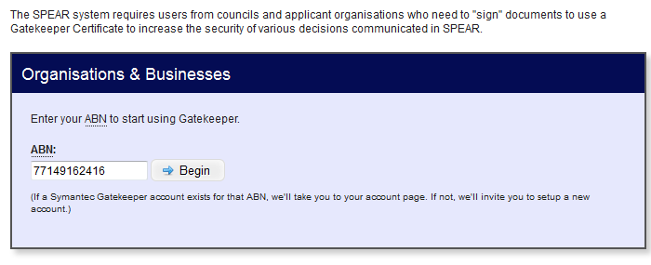
Type your organisation’s ABN number (without spaces) into the box provided and click ‘Begin’.
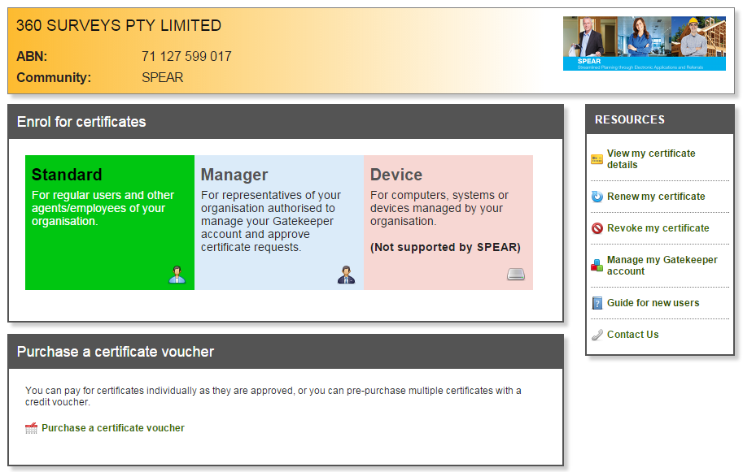
Select Manager and click the link to ‘Enrol for a new Manager certificate’.
32.2 Enrolment:
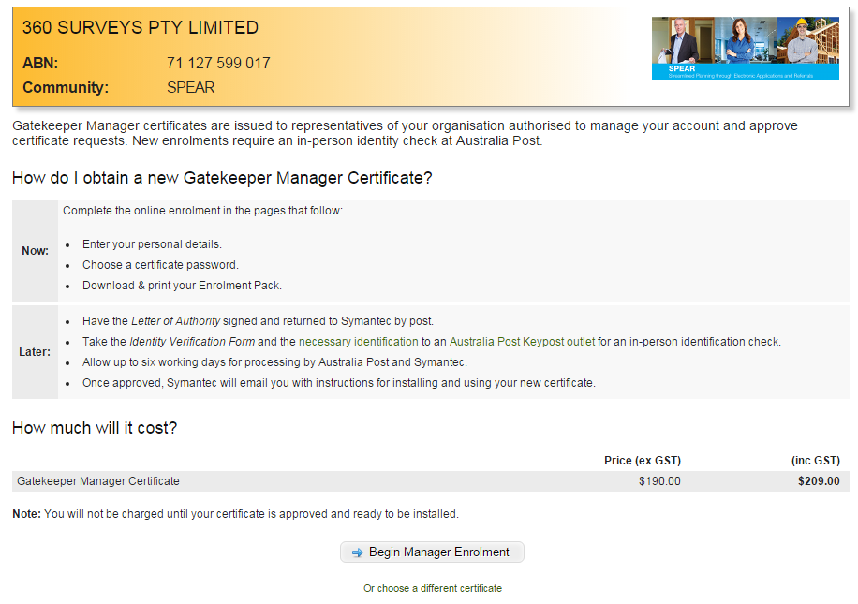
Review the instructions then click ‘Begin Manager Enrolment’.
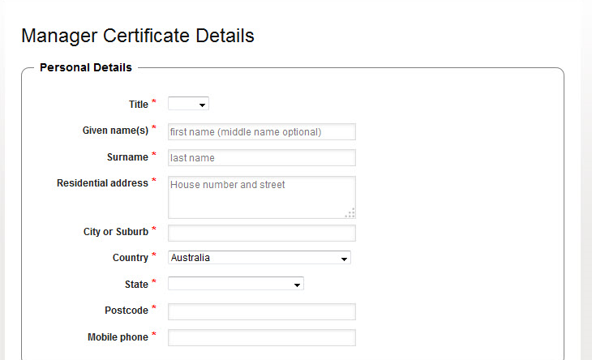
A mobile phone number is required for the installation process.

Complete your details. Note these details must match your photo ID.
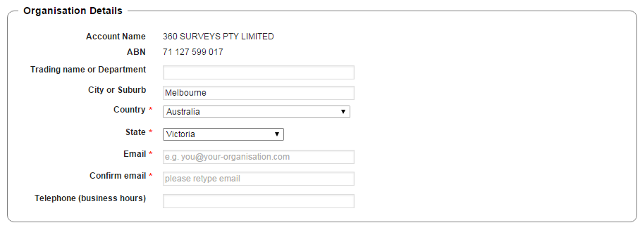
Enter your organisation details and your email address.

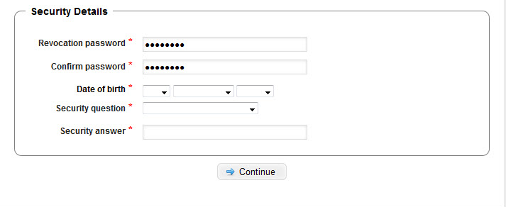
Enter a Revocation password.
Complete DOB and security questions.

The revocation password and security answer are required if you need to replace or cancel your digital certificate. Please record both in a safe place.
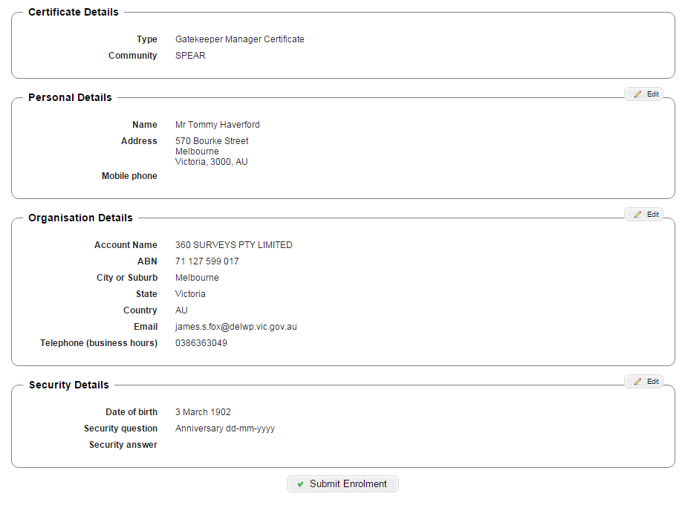
Confirm your enrolment details are correct. Click ‘Edit’ if any details are incorrect.
If all details are correct, click ‘Submit Enrolment’.

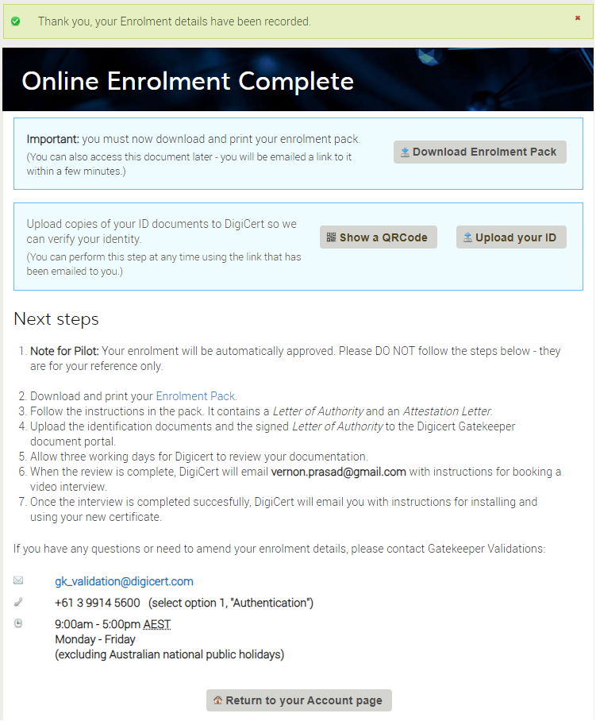
The next step is to download the Enrolment pack either from the screen above or from the email DigiCert will send to you. This will provide you with more instructions, including uploading the Letter of Authority and completing the Identity Verification.
Once DigiCert have reviewed your documentation and successfully completed a video interview with you, they will email you with instructions for installing and using your new certificate.
Need more information?
Further information on this topic can be found by:
- Visiting the SPEAR website www.spear.land.vic.gov.au/SPEAR.
- Contacting the SPEAR Service Desk on 9194 0612 or email spear.info@delwp.vic.gov.au

